02.219: Rice cultures: Technology, Society, and Environment in Asia

Laura Ong Jin Hua 1002464

Xiaoyi Gong 1004084

Shek Kin Long Ronald 1004082

Li Yuluan 1002183

Rice Lab Notebook

**Hypothesis**2

**Reference**2

**Materials used for this experiment**2

**Methods**2

Observation Method 2

Experimental Method 2

**Data**3

**Results and Discussion**4

Interpretation of Data 4

Is your hypothesis supported or rejected? 5

What are the limitations of the study 5

**Appendix**6

# Hypothesis

Rice grown under nutrition from husks is better than rice grown in traditional fertilizer.

# Reference

Lim, S. L., Wu, T. Y., Sim, E. Y., Lim, P. N., & Clarke, C. (2012). Biotransformation of rice husk into organic fertilizer through vermicomposting. *Ecological Engineering,* *41*, 60-64. doi:10.1016/j.ecoleng.2012.01.011

Growing Strawberries and other cool stuff in singapore. Retrieved 8 Feb 2019 from <https://sgstrawberries.com/2016/03/05/apartments-rice-paddies/>

# Materials used for this experiment

1. Potting Soil
2. Three Pots for rices that are growing under different conditions
3. Wet Media (i.e. water, taken from the tap with a ph of 8.4)
4. Rice Husks[1] ([sourced from Far East Flora](https://www.fareastfloragarden.com/rice-husk-prepack-5l.html))
5. Fertilizer (A smaller version of [this](https://www.facebook.com/commerce/products/1081938938563694/?rid=138060429563390&rt=6))

# 

# Methods

## Observation Method

After germination, our team measured the height of the plant every 2 - 3 days to check on growth rate. Final examination is to be done by examining the root system as well as the overall height of the plant.

## Experimental Method

The control was filled with 100% potting soil mix, while the second was given a 10% rice husks, 20% fertilizer, as well as a 70% potting soil mix. We had another control with a 70% potting soil mix and 30% fertilizer ratio.

# Data

|  |  |  |  |
| --- | --- | --- | --- |
| Date | Control (cm) | Fertilizer (cm) | Rice Husk (cm) |
| 3/4/2019 | 2.76 | 1.3 | 1 |
| 3/7/2019 | 5 | 3.6 | 2.3 |
| 3/8/2019 | 5.9 | 4.2 | 3 |
| 3/9/2019 | 7 | 5 | 3.6 |
| 3/12/2019 | 12 | 8.2 | 6 |
| 3/16/2019 | 12.6 | 8.3 | 6.2 |
| 3/19/2019 | 14.2 | 6.5 | 4 |
| 3/22/2019 | 14.2 | 5.3 | 3.8 |
| 3/25/2019 | 14 | 3.8 | 0 |
| 3/27/2019 | 13.8 | 2.1 | 0 |
| 3/29/2019 | 12 | 0 | 0 |
| 4/3/2019 | 11 | 0 | 0 |
| 4/5/2019 | 11 | 2 | 0 |
| 4/8/2019 | 14 | 4 | 0 |
| 4/11/2019 | 14.2 | 6 | 0 |
| 4/15/2019 | 15.5 | 8 | 0 |
| 4/17/2019 | 16.5 | 9 | 0 |
| 4/22/2019 | 18 | 9.1 | 0 |
| 4/24/2019 | 21.8 | 9.1 | 0 |
| 4/25/2019 | 22.2 | 9.1 | 0 |

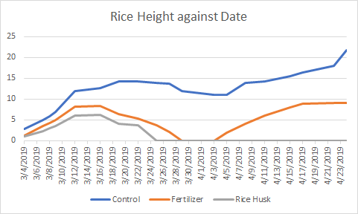

# Results and Discussion:

## Interpretation of Data:

The fastest growth period is at the germination stage, between 4th March to 12th March. From the graph, we can see that all three pots have the largest gradient during that period of time, after which plant growth displays a logarithmic growth.

We see a mass death in the on the 19th of March, where the rice plants have started to die (as we measured the height of the tallest *green* shoot, rather than the overall height). It is likely that 15 days after the rice plants have started growing, the excess water had contributed to overwatering[2], which led to a loss of vigor (and the slow down in growth rate up till that point) as well as the ‘clamping’ of leaves where the seedlings become thinner the longer they grow. Hence, by the 29th of March, or 25 days after germination, all plants have experienced some loss of growth, and thus a decrease in height.

While the **Control Experiment** and **Fertilizer Experiment** showed signs of recovery after cutting down on watering frequency, the **Rice Husk Experiment** rapidly declined and never recovered. We attribute this to rice husks present not absorbing the excess water and contributing to rapid plant death.

In fact, a closer look at our sources state:

“However, decreases in magnesium (3.7–45.7%) and nitrogen (6.9–23.7%) were also observed in final vermicomposts.” [3]

We conclude that Rice Husks introduced a fragility to the experiment, thus leading to an ecological collapse which **Control Experiment** and **Fertilizer Experiment** survived.

An introduction of a new variable into the ecosystem may result in both positive and negative impact. The original purpose of adding fertilizer was to boost rice growth, however adding fertilizer had also added fragility into the system as it may contain more nutrition than what the rice plants needed. For the **Rice Husk Experiment**, it introduced two new variables; rice husks and fertilizer; which weakened the ecosystem.

The experimental results provoke thought about how humans intervene in the natural environment. There are beneficial and effective practices which bring positive outcomes; on the other hand, there are cases where humans had intervened to the detriment of the environment. For instance, the introduction of DDT in the 1950s for crops in the U.S had at first achieved desired results as pests could be eliminated effectively; however, the side effects in the long run were neglected which led to the death of people who consumed those crops.

## Is your hypothesis supported or rejected?

We reject our hypothesis as we found that **Rice Husk Experiment** grew at a slower rate, and was quicker to die off as compared to **Control Experiment**  and **Fertilizer Experiment**.

## What are the limitations of the study

We noted in our Appendix that in the third and last weeks of March, there was heavy weather and strong winds, leading to our **Control Experiment** visibly deteriorating under the increased wind stress. Thus, we felt that there was rapidly changing conditions present, and this led to an incomplete study.

Furthermore, we were unable to predict the nutrient levels of our soil and fertilizer. As noted in our interpretation, our sources state that nitrogen levels drop under the addition of Rice Husks. Therefore, we would like to have been able to monitor nutrient levels in order to provide intervention once we found the plants dying.

We noted that we were unable to predict overwatering, and thus resulted in a rapid death before one month into the experiment. We hope that there would be future studies on the water to soil ratio, as we felt that the rice husks had led to waterlogging and thus a decline in plant growth.

# Appendix

Monday, 25 Feb 2019

We started planting our rice plants on that day. The control was filled with 100% potting soil mix, while the second was given a 10% rice husks, 20% fertilizer, as well as a 70% potting soil mix. To act as contrast, we had another control with a 70% potting soil mix and 30% fertilizer ratio.

To promote growth, we decided to have the seeds germinate in a tissue paper + water mix as illustrated by this:

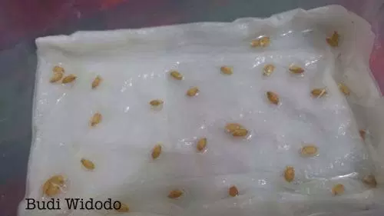  
*Retrieved from Apartments’ Rice Paddies, at* [*https://sgstrawberries.com/2016/03/05/apartments-rice-paddies/*](https://sgstrawberries.com/2016/03/05/apartments-rice-paddies/) *on 24/4/2019*

We felt that this had potential as earlier experiments with mung bean had them sprouting within the next 36 hours.

Wednesday, 27 Feb 2019

None of the seeds have germinated.

Monday, 4 March 2019

We noted that the seeds have germinated. This gives us an estimate of **1 week** before the seeds started sprouting. As noted by [this website](https://sgstrawberries.com/2016/03/05/apartments-rice-paddies/), this was normal.

However, other groups have had their seeds germinated long before us. It was felt that the potting soil provided a better environment for this variety of seeds to germinate, as opposed to growing it on tissue paper.

Wednesday, 6 March 2019

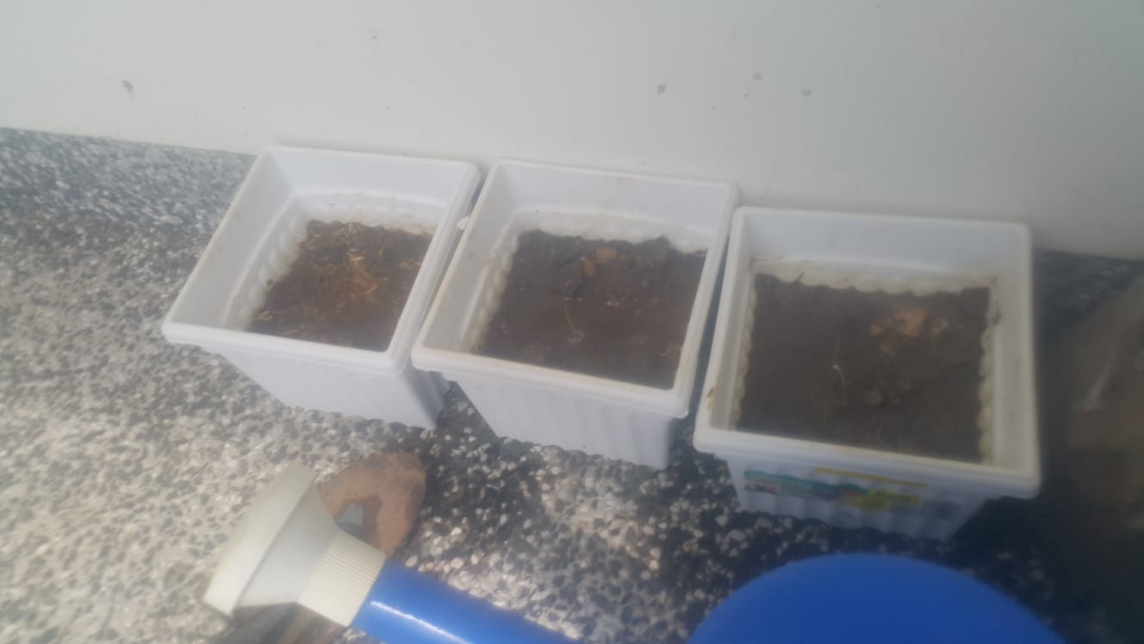

As seen in the photo, the one on the right, the **Control**, has shown three shoots. On the other hand, the one on the left, the **Rice Husk Experiment,** has barely only one shoot. At this point of time, we felt that we would have to reject our hypothesis

Thursday, 7 March 2019

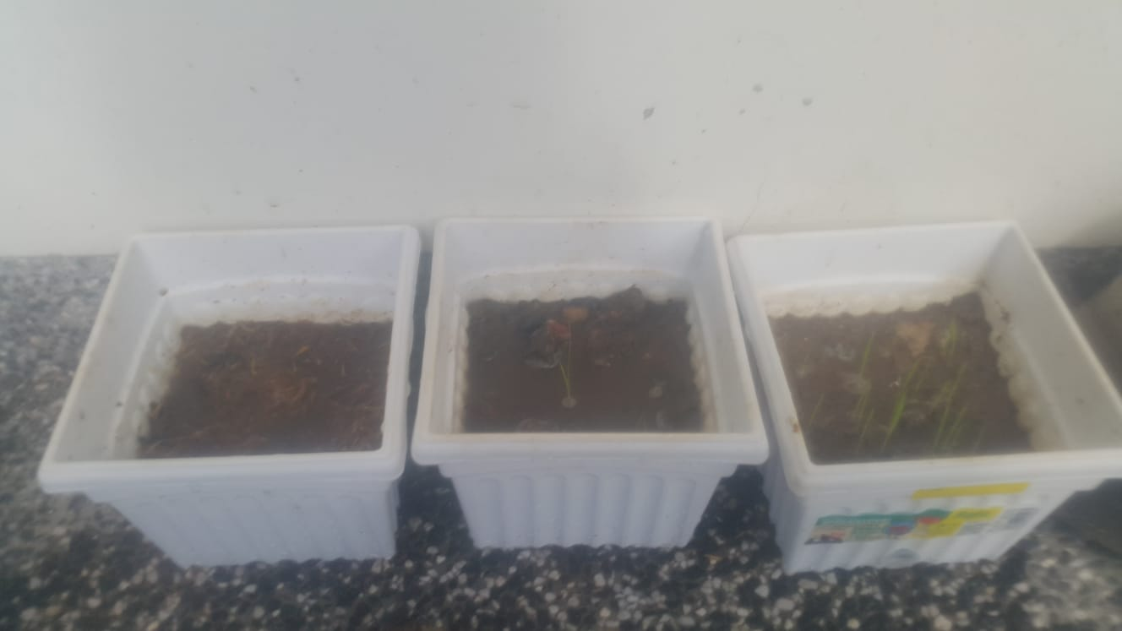

Our hypothesis was not supported, judging by the growth in the number of seeds that have germinated in the **Control Experiment** as opposed to the rice husks.

Friday, 8 March 2019

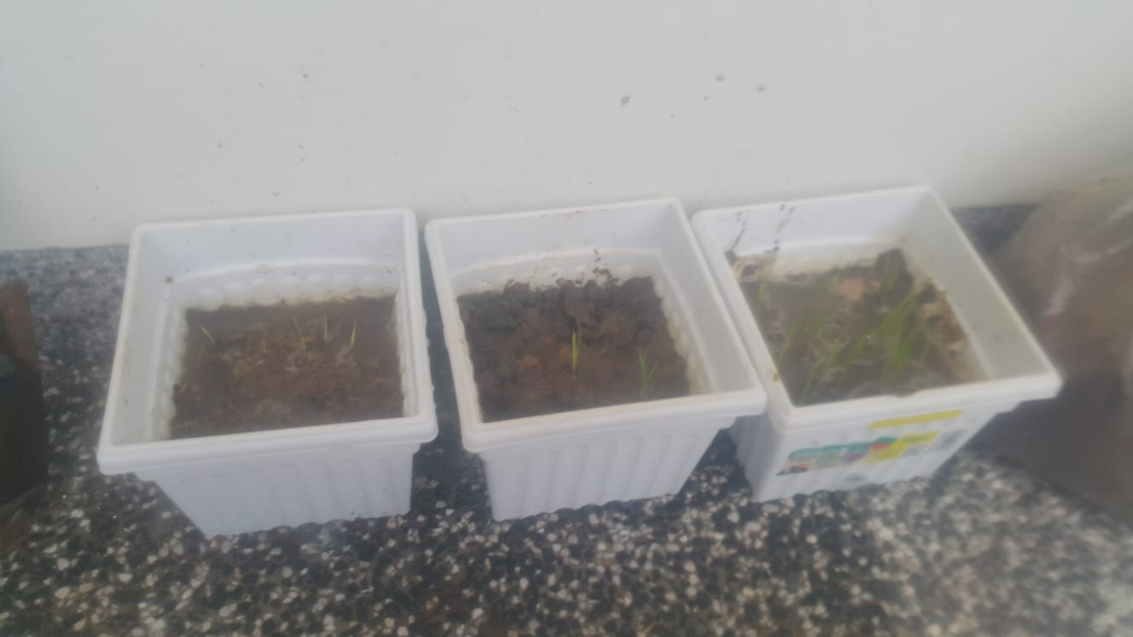

We see more seeds germinating in the **Rice Husk Experiment,** but all seedlings show signs of yellowing in both the **Rice Husk Experiment** and **Fertilizer Experiment.**

We guessed that it was due to “Overwatering”, based on [this chart](http://www.saferbrand.com/articles/plants-turning-yellow). This is because the same amount of water was applied to all three pots, and that while flooding of the fields occurred, all pots absorbed different amounts of water content. We observed by touch that the **Rice Husk Experiment** had a wet mulch as compared to the **Control Experiment.** We guessed that due to the rice husks being unable to absorb the water as efficiently as the regular potting soil mix, this results in the rice plants being overwatered.

Saturday, 9 March 2019

Over the course of recess week, one member (Laura) took the plants back to their house to look after them. It was felt after a group decision that we shall move the watering schedule from once a day to once every two days to resolve the issue of overwatering.

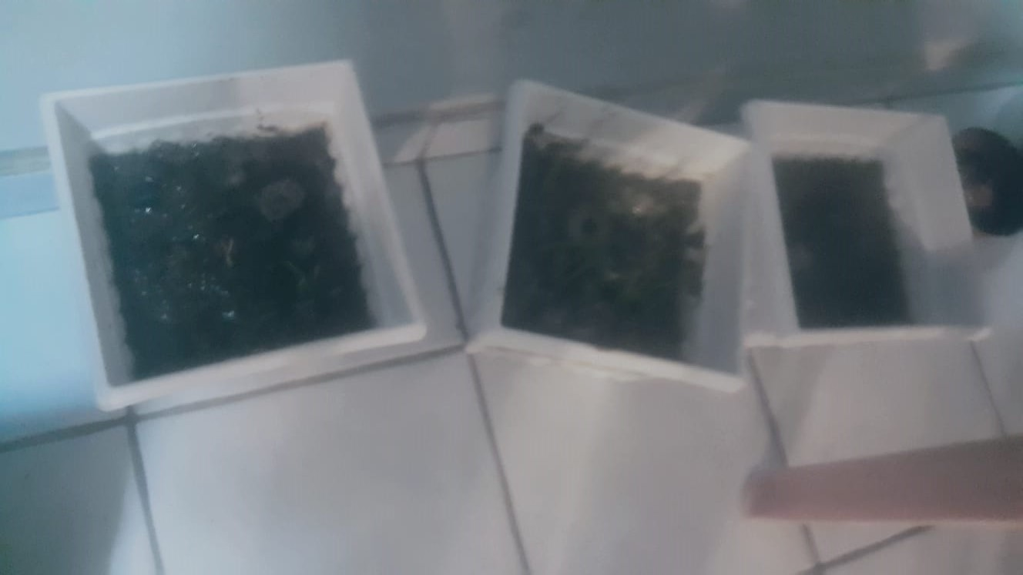

Saturday, 16 March 2019

We believed that adding the fertilizer had resulted in the plants experiencing nutrient poisoning, after examining the plants of other groups. 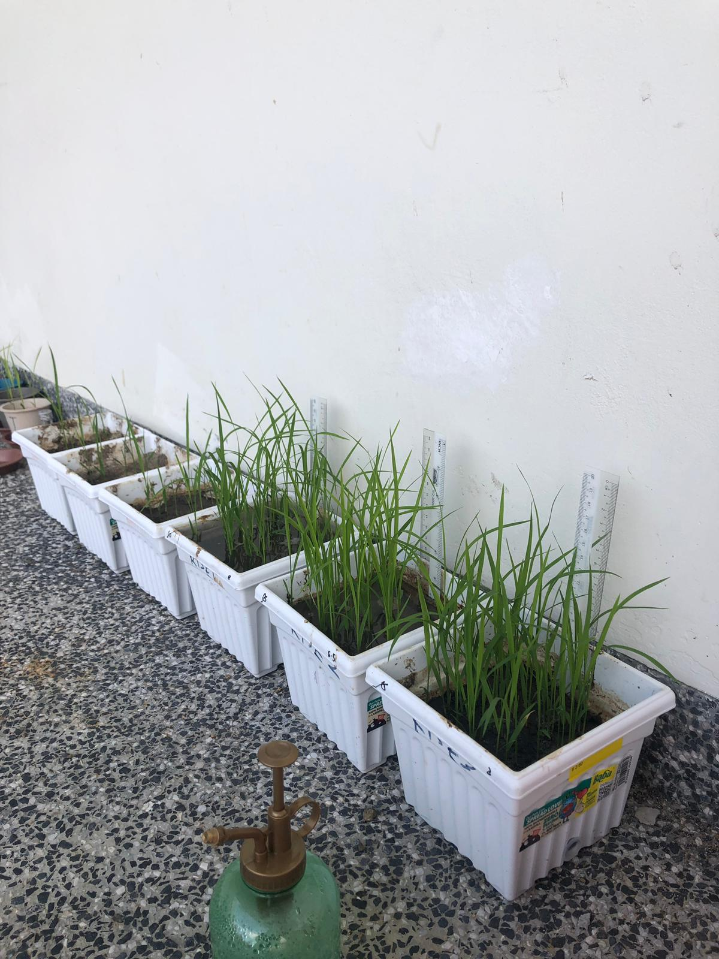

*Growth of Rice Plants of other groups, 12 March 2019*

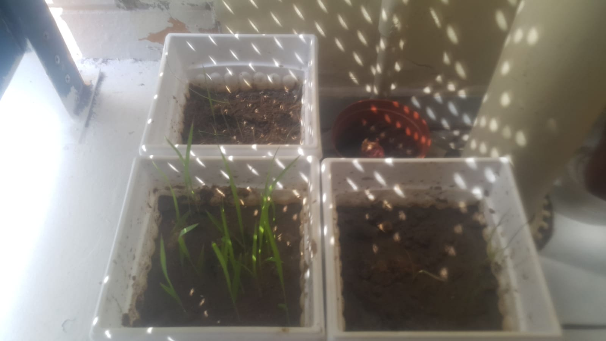

*Our plants, taken 16 March.*

We noted that while those in the potting soil mix looked healthy, both **Rice Husk Experiment and Fertilizer Experiment** had their leaves curling up. A match to [this website](http://www.saferbrand.com/articles/leaves-foliage-problems) gave us **Nitrogen Deficiency** as a possible source. However, our fears of that being of a Nitrogen deficiency problem were mistaken, as a further check to the fertilizer we used showed that there was a source of Nitrogen in the packet. 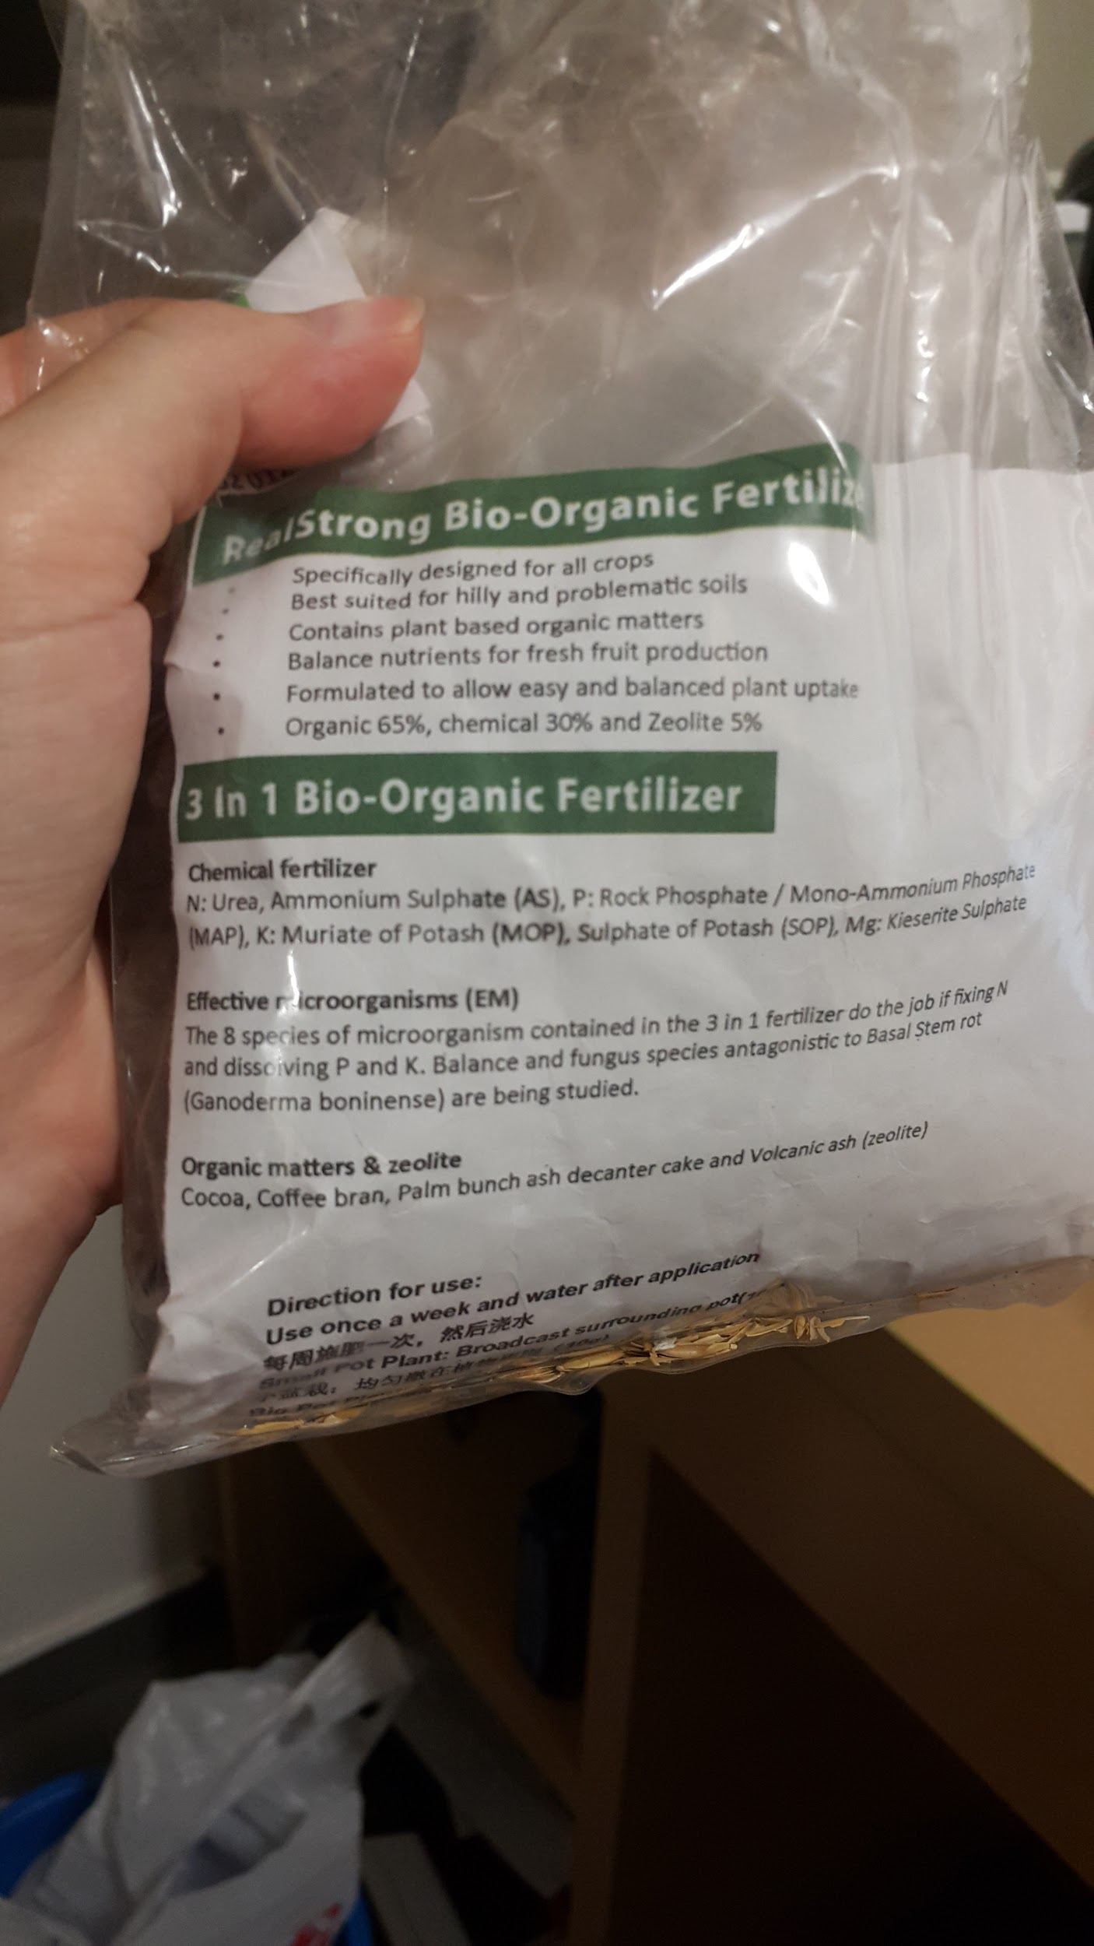

Monday, 18 March 2019

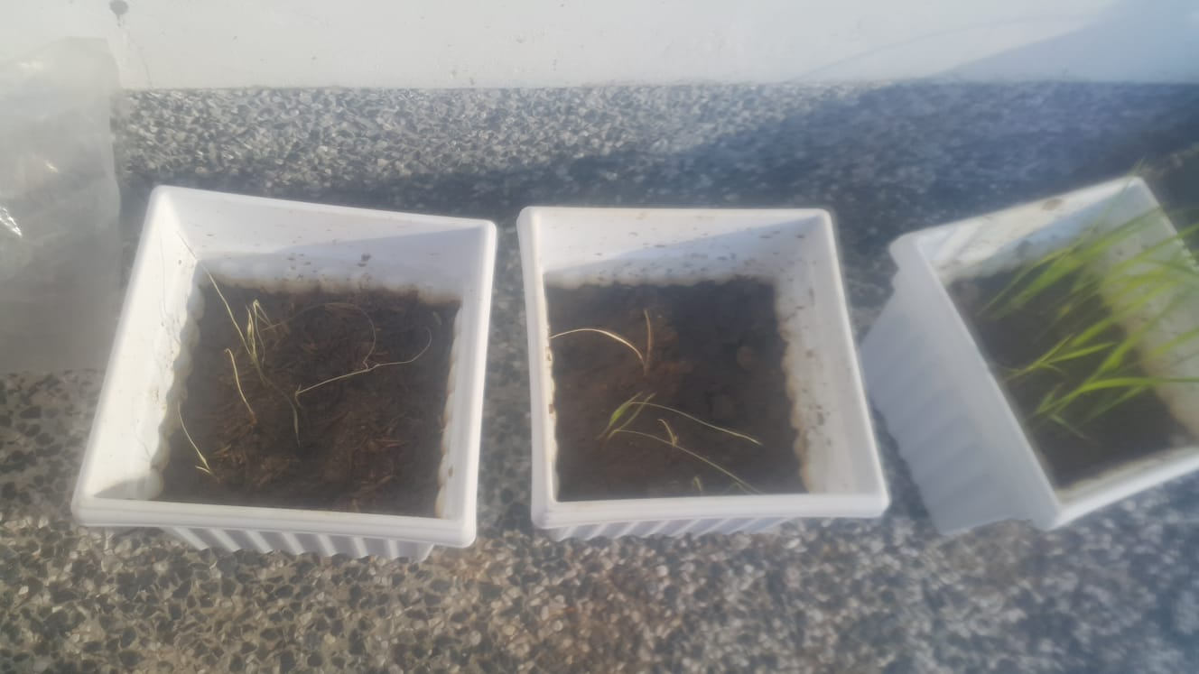

As earlier tracked, while those of the **Control Experiment** were relatively healthy, both **Rice Husk Experiment** and **Fertilizer Experiment** displayed curling stems and weak shoots. In addition, some of them had already started withering away.

We came to the conclusion that with the reduction in potting soil in the ratio, there was improper drainage, and therefore the soil retained much more water, causing the **Rice Husk Experiment** and **Fertilizer Experiment** to display signs of overwatering.

While this may not occur in a large field setting, as we were currently keeping them in pots, the soil was not able to properly dry out in response to plant demand.

Tuesday, 26 March 2019

As seen in the picture, even under the best conditions, there is a fragile balance between that of watering and that of non-watering. We see that as soon as one of the rice plants dies off in the **Control Experiment,** the rest of the plants immediately start to show effects of overwatering and start to wilt. Both the **Rice Husk Experiment** and **Fertilizer Experiment** have wilted fully and we stopped our experiment.

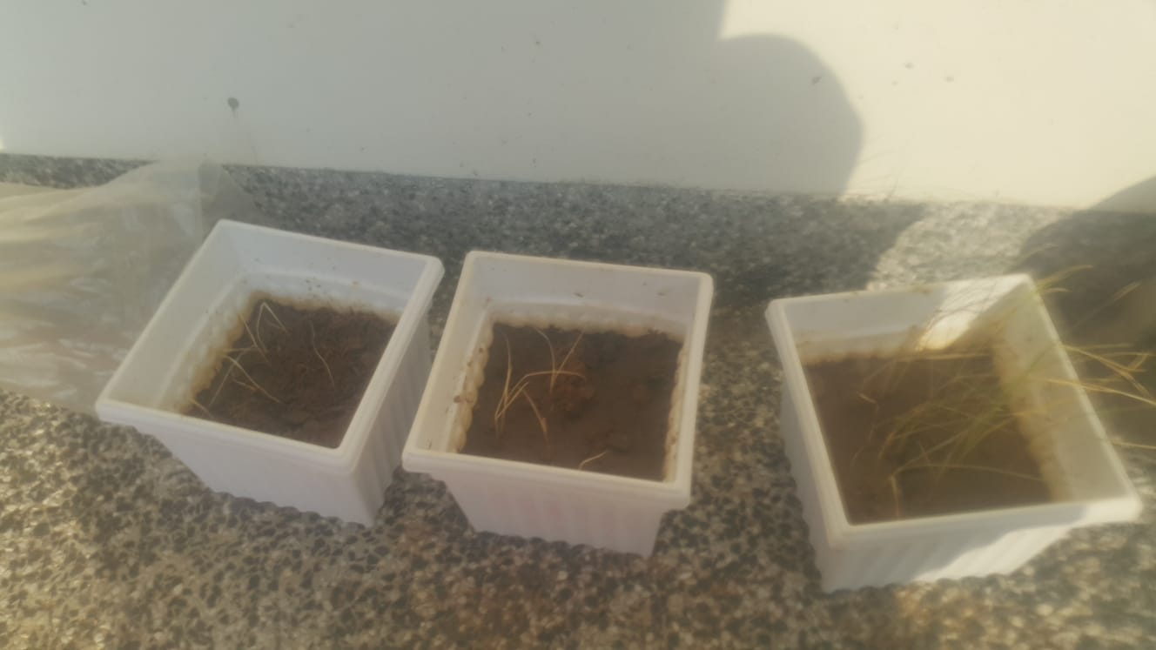

Wednesday, 27 March 2019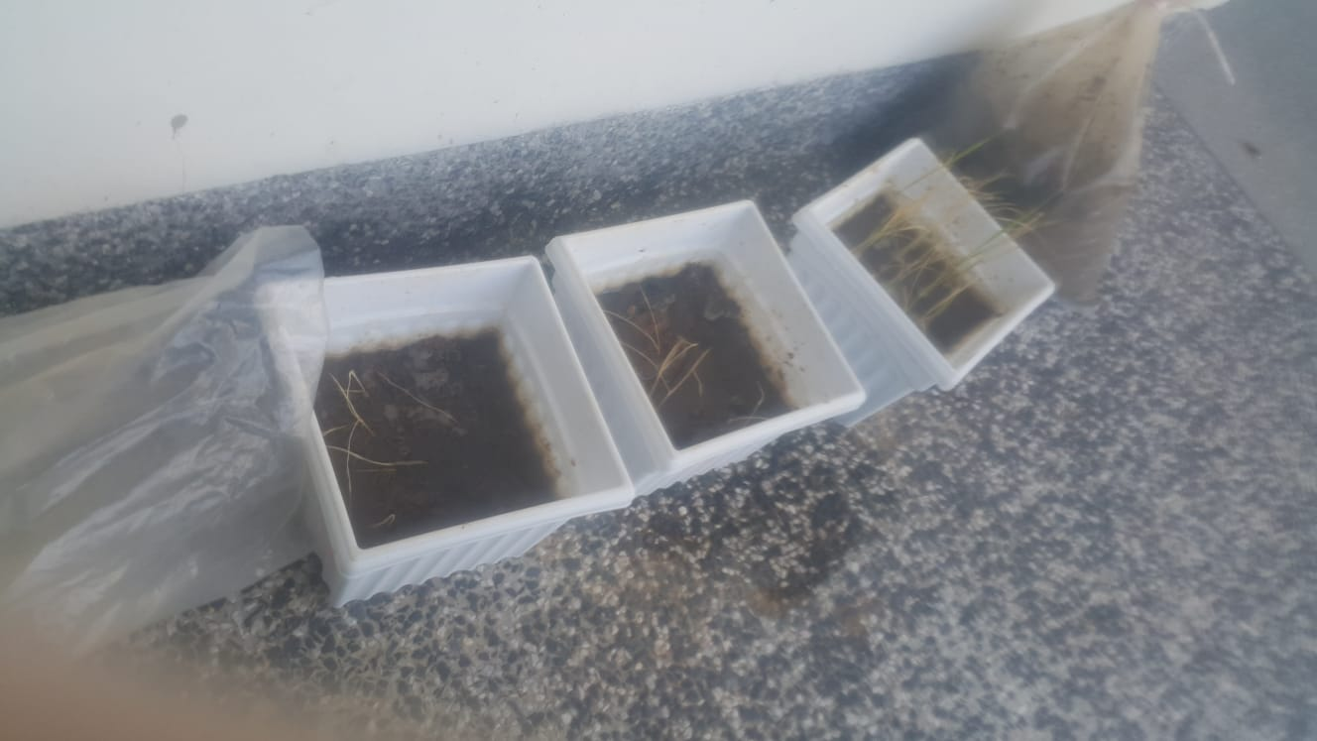

We still see mass deaths, with only the **Control Experiment** barely surviving. However, new shoots are appearing, as the breakdown in old plants provided nutrients for new shoots to appear.

Friday, 29 March 2019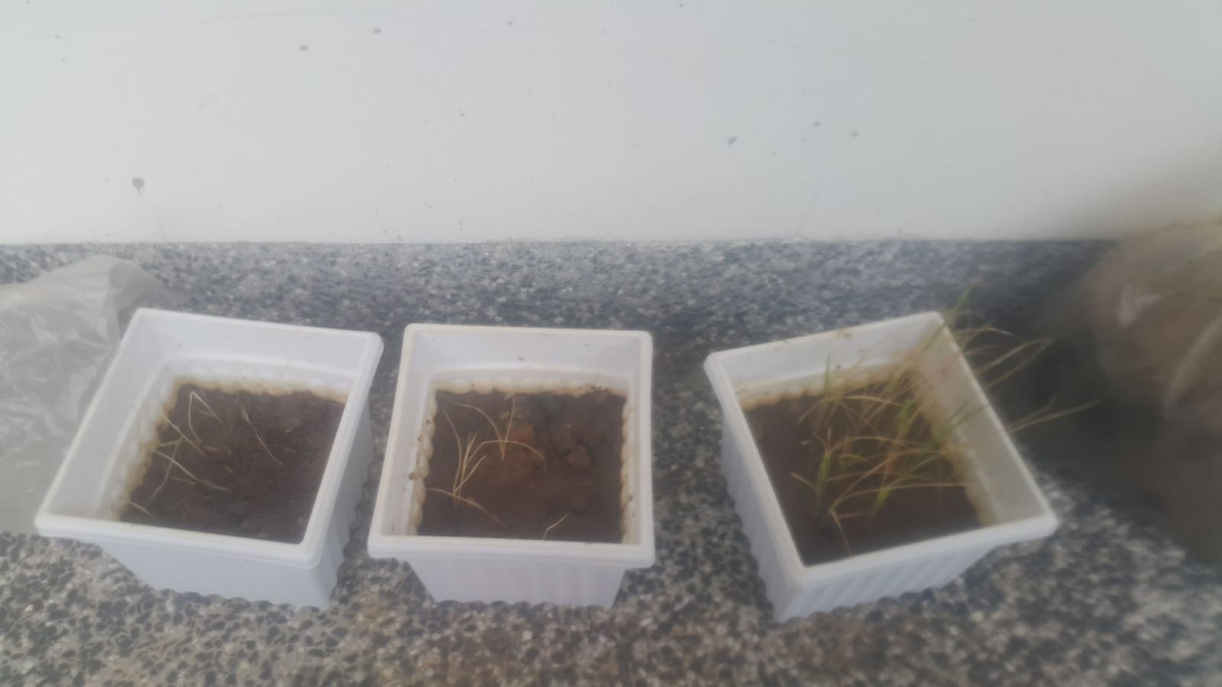

We see further signs of recovery in the **Control Experiment** as we drastically reduced the watering frequency to three times a week rather than once every two days.

Between 22 March 2019 to 3 April 2019

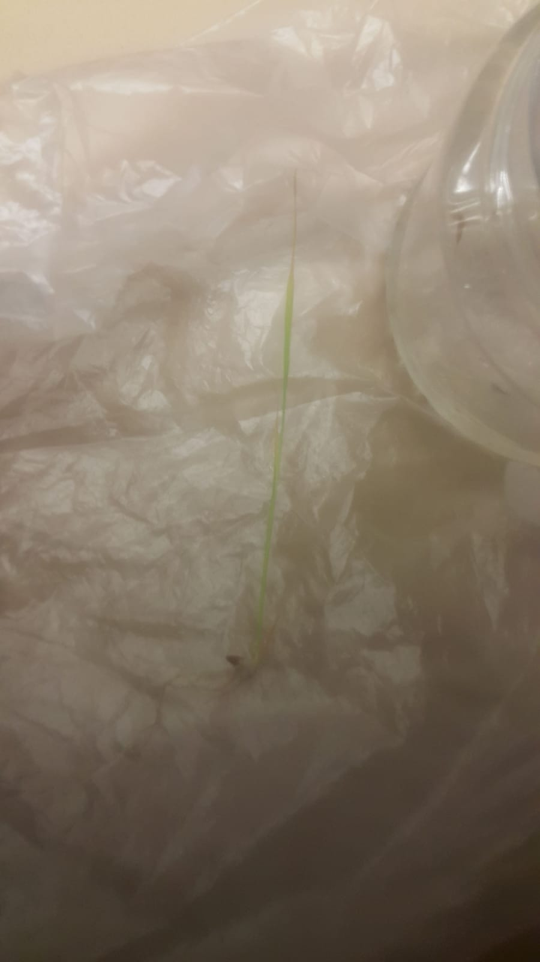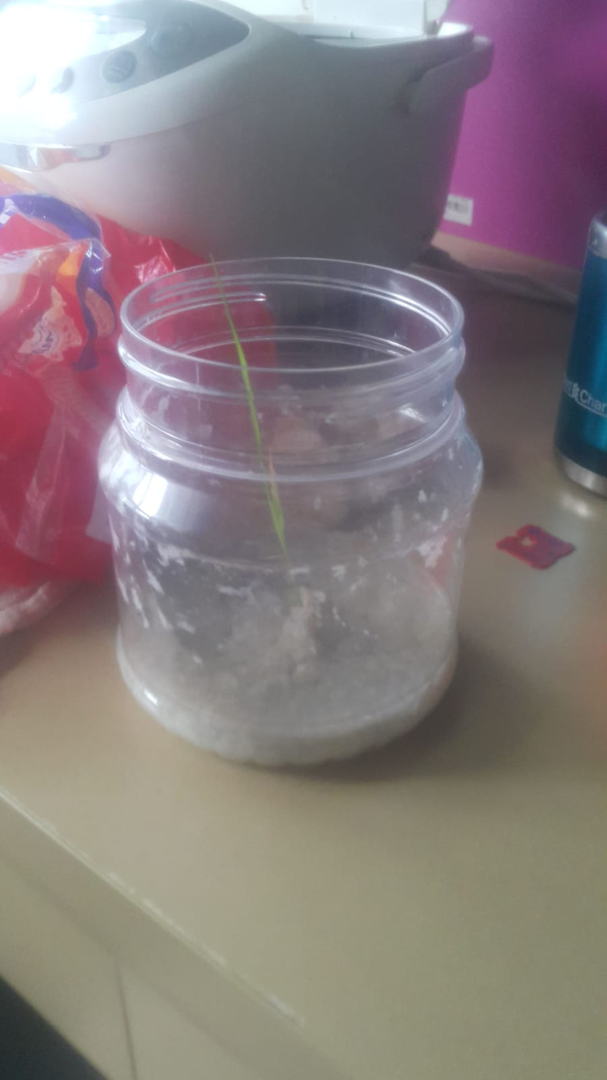

*Restart of our Rice Lab. Height of this seedling is approximately 12.6 cm in height, which is taller than our Control Plants by then.*

Tuesday, 9 April 2019

Our seedlings have experienced 18 days of growth. However, we have once again seen the phenomena of clamped leaves, leading us to conclude that overwatering of seedlings do tend to lead to plants wilting. 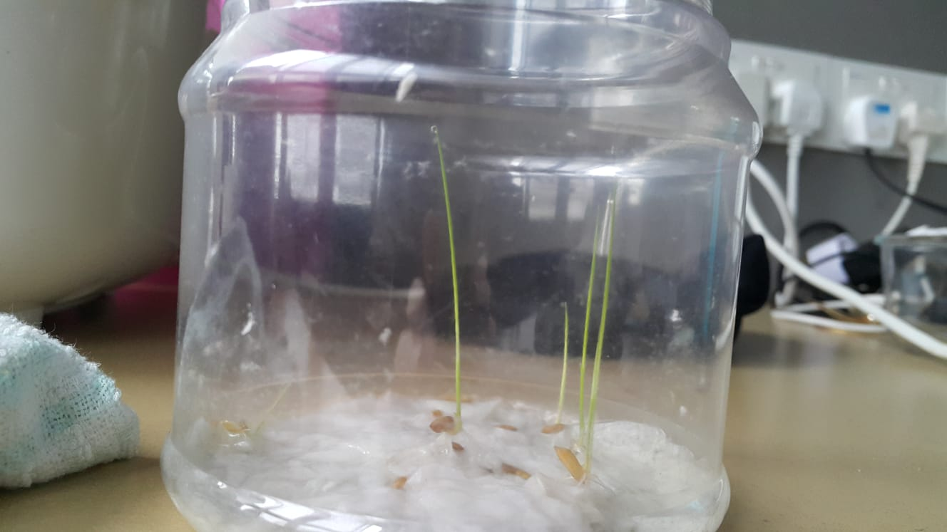

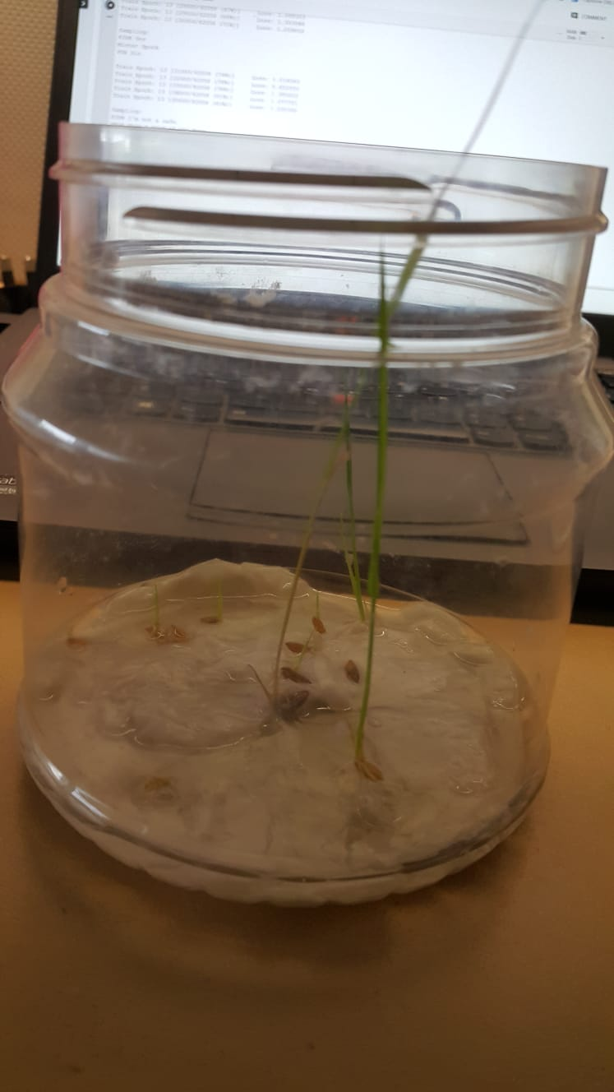

At the same time, due to heavy rain and strong winds, we found that our plants at the Fab Lab have been severely affected.

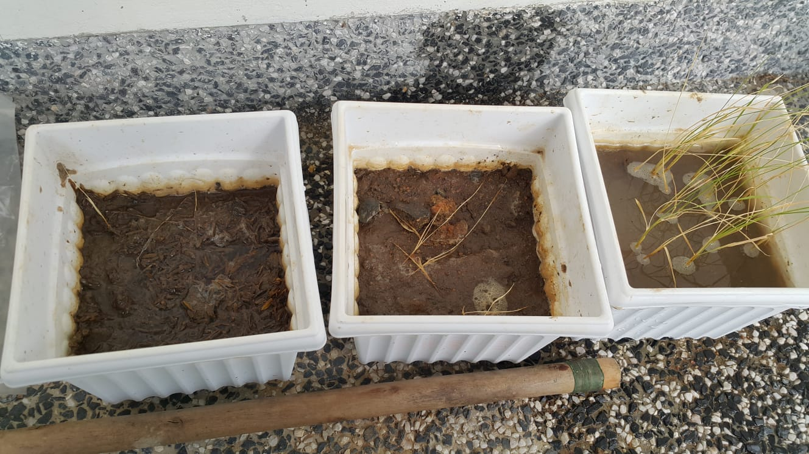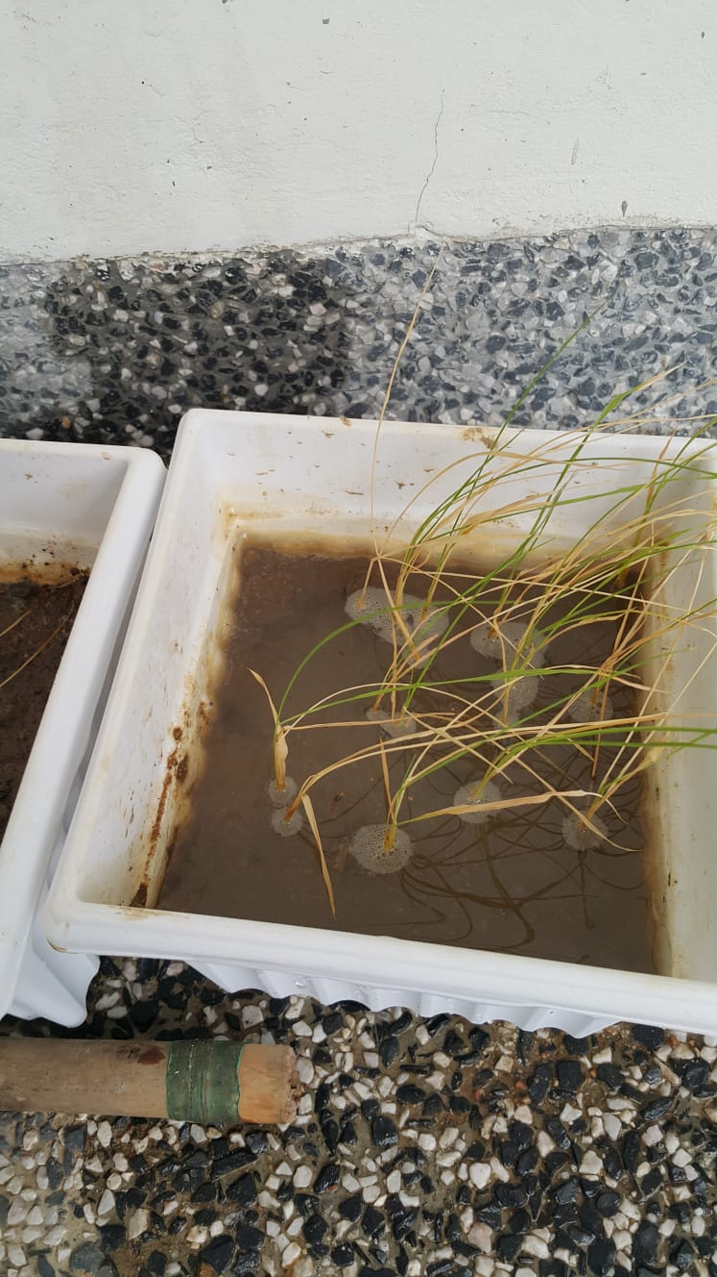

We see that all of the leaves in the **Control Experiment** are now clamped. In addition, we see that they are all wilting in one direction due to the strong winds present. Due to their weak stems, they did not survive as well as the rice plants belonging to other groups.

Wednesday, 10 April 2019

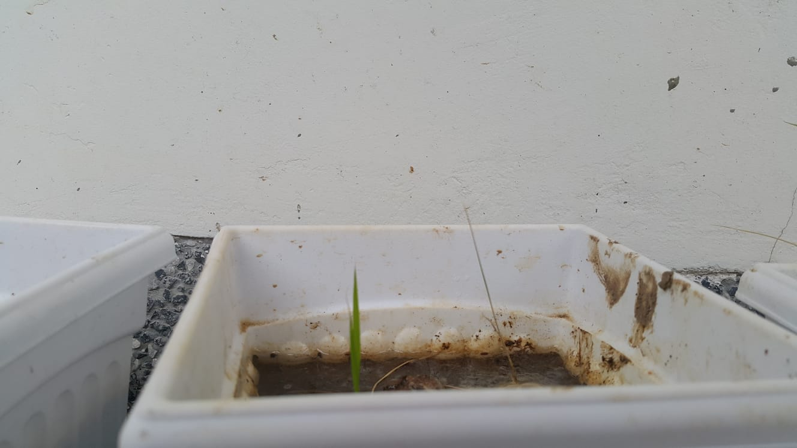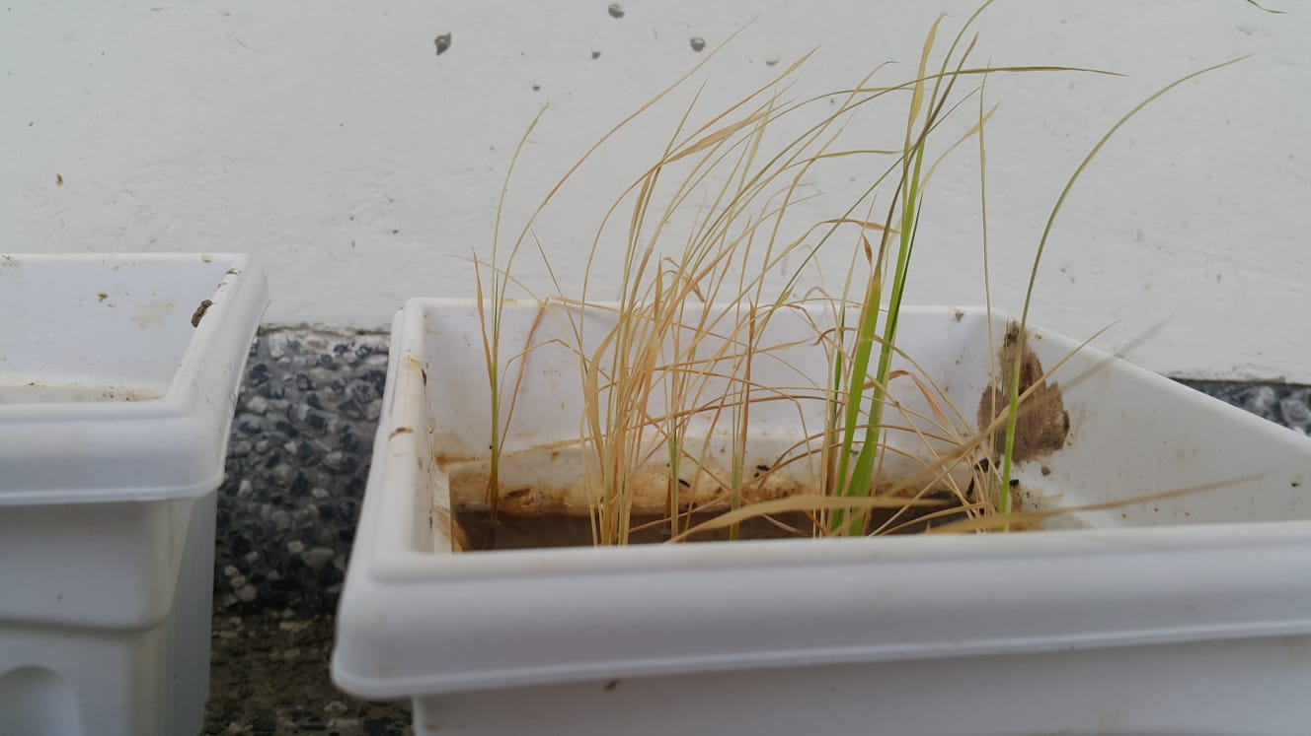

We see surprising growth in the **Fertilizer Experiment** while the **Control Experiment** responded to the reduction in watering by sprouting new leaves.

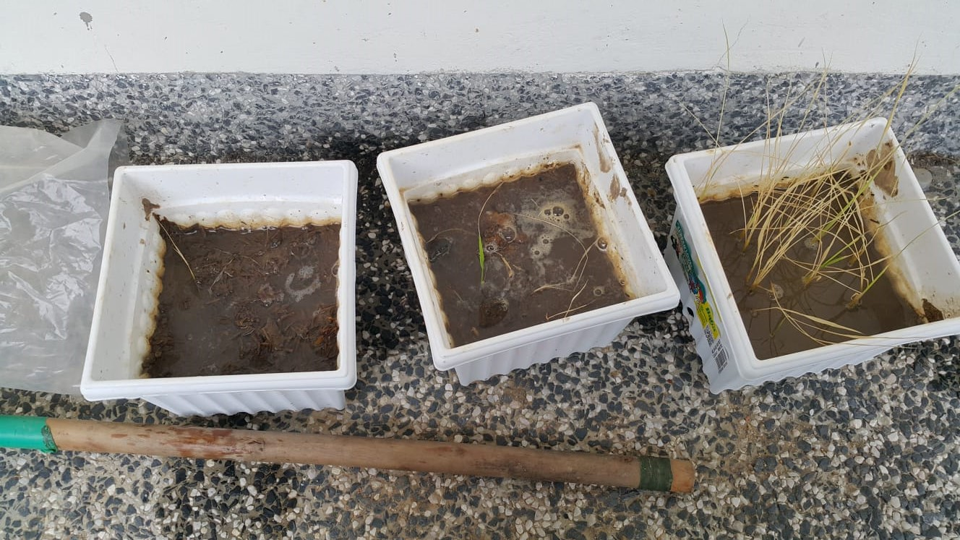

Thursday, 11 April 2019

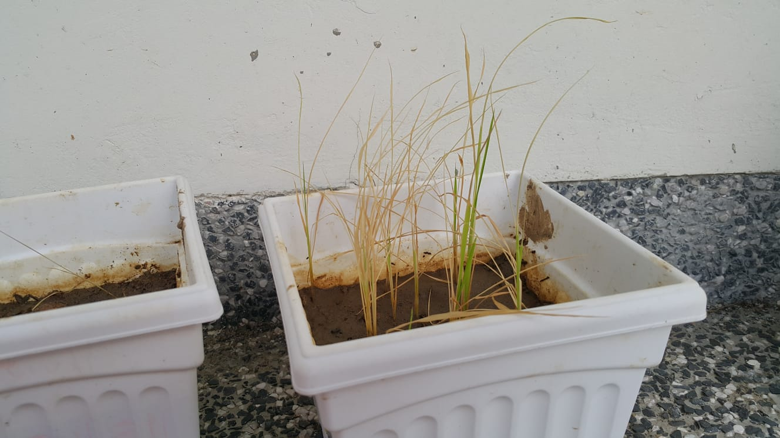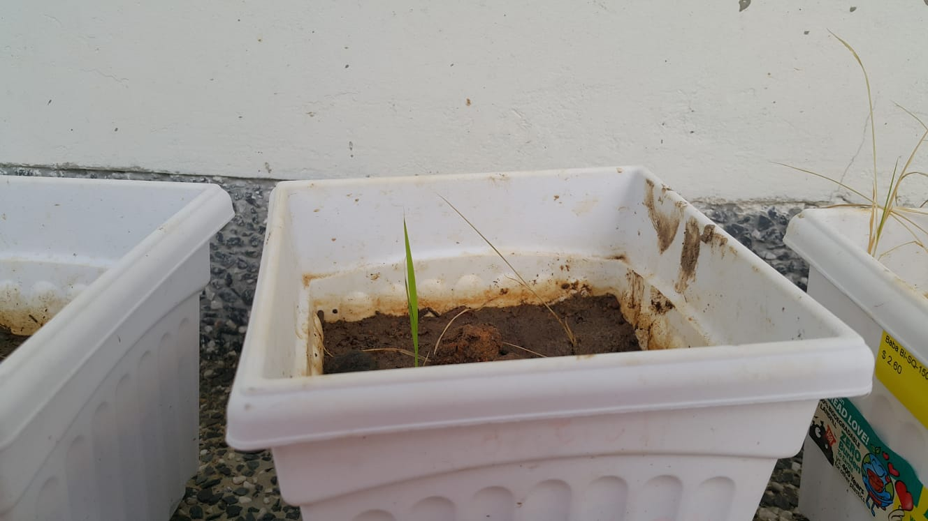

There was further improvement in growth. 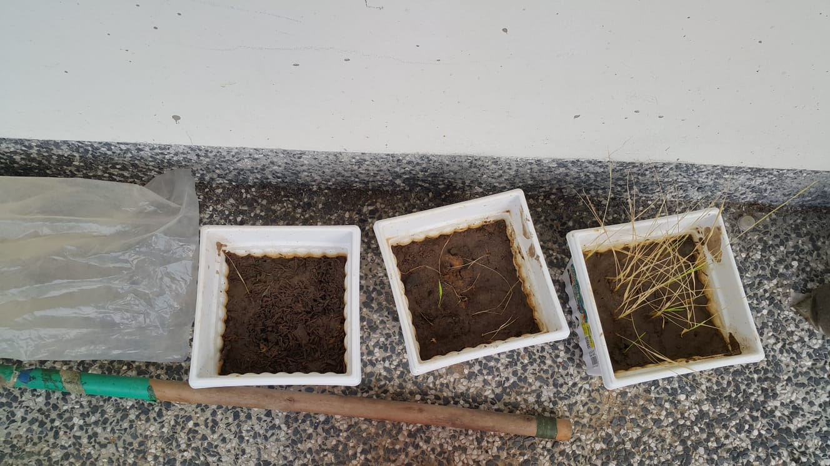

Monday, 15 April 2019

We decided to remove seedlings for closer examination. It was only then that we noticed, that taking out the root system was a sound theory, but when uprooting the rice plants, we could not get a complete sample. the root was firmly immersed in the soil that we could remove the plants from the stem up. 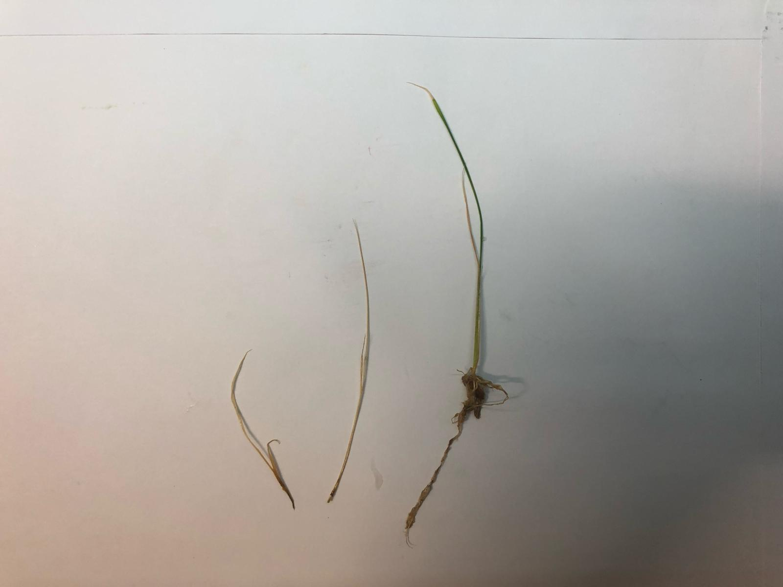

Wednesday 24 April 2019

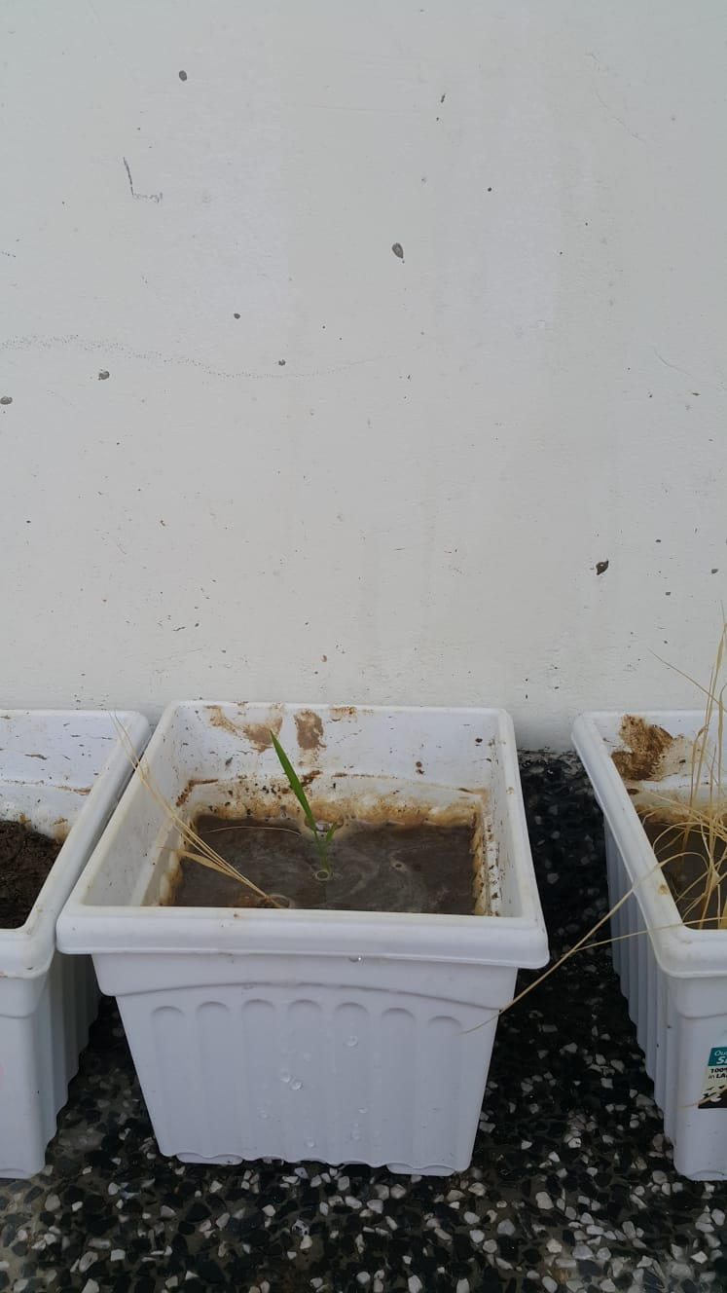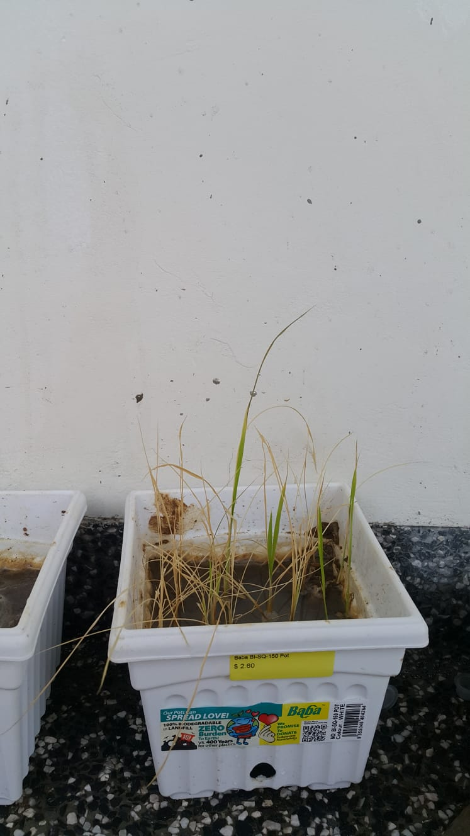

Our secondary hypothesis, that we had been over watering our plants and thus the reason for our failure, was proved as seen in the healthier growth after our restart.

Thursday 25 April 2019

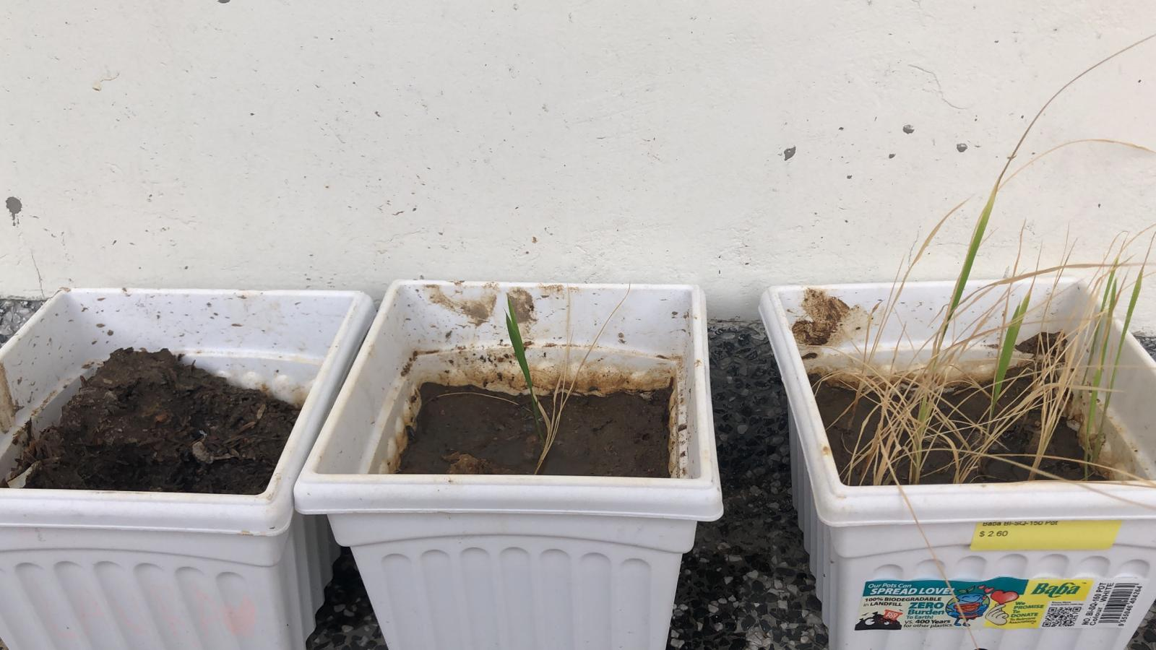

1. Rice Husk - Prepack (5L). (n.d.). Retrieved April 25, 2019, from https://www.fareastfloragarden.com/rice-husk-prepack-5l.html
2. What is Overwatering? - Definition from MaximumYield. (n.d.). Retrieved from https://www.maximumyield.com/definition/3238/overwatering
3. Lim, S. L., Wu, T. Y., Sim, E. Y. S., Lim, P. N., & Clarke, C. M. (2012). Biotransformation of rice husk into organic fertilizer through vermicomposting. *Ecological Engineering*, *41*, 60 - 64. https://doi.org/10.1016/j.ecoleng.2012.01.011